Bash Scripting Tutorial 2
- Create a bash script to check if a directory is available or not.
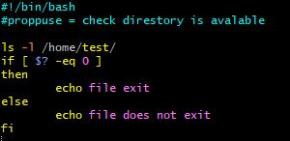

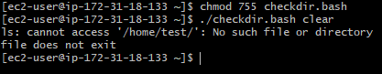

- Create a bash script to create multiple files.
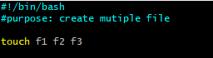

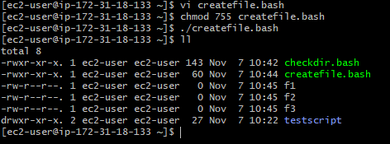

- Create a bash script to take a backup of a directory.

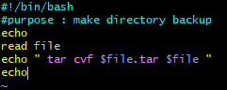

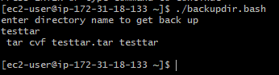
- Create a bash script to install Nginx on an EC2 server.
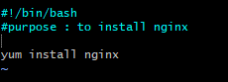
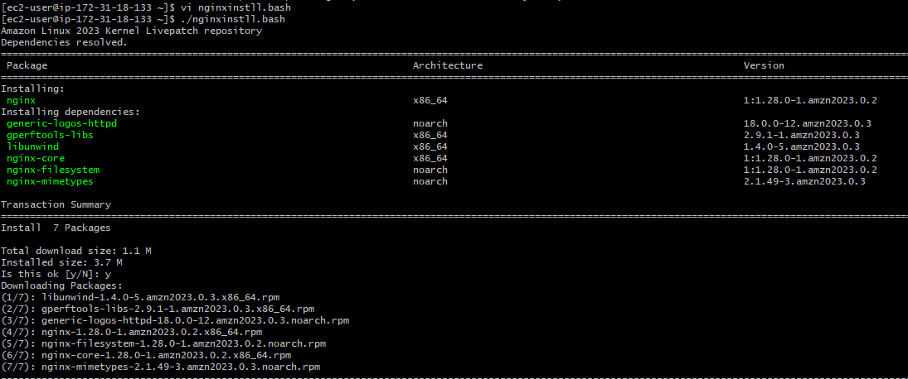

- Create a bash script to install Apache Tomcat on an EC2 server.
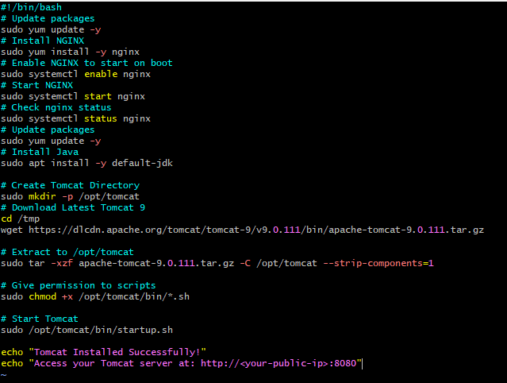
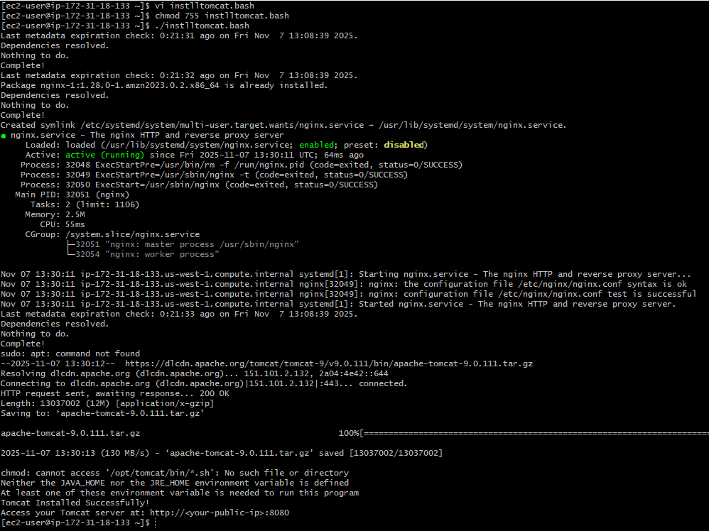

6.Create a bash script to check if the Nginx service is running, if not running then script should start the service.
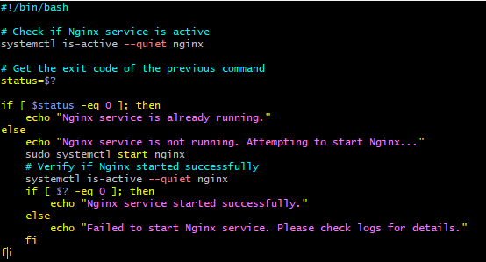
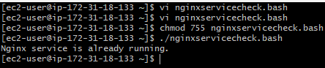
7.Create a bash script for a calculator.
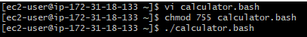
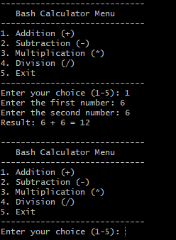
8. Create a bash script to check if a directory exists, if not then create a directory.
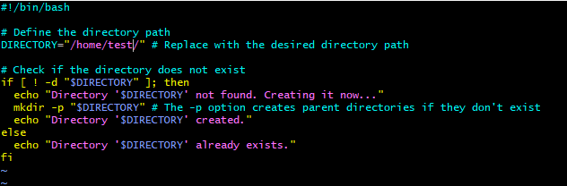
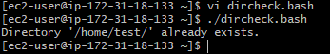
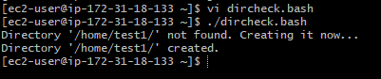
9. Create a bash script to delete the last 3 lines of a file.
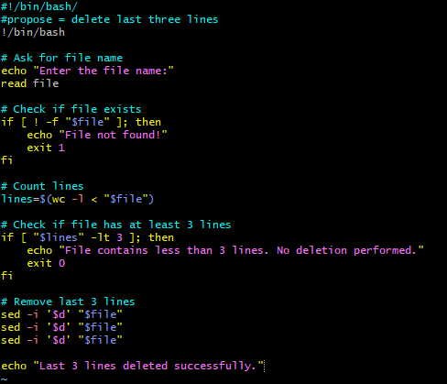
10. Bash script to monitor cpu and if it is more than 80% then send email notification.
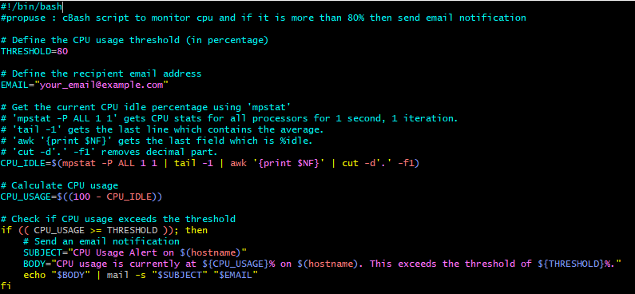

11. Bash script to monitor disk space and if it is more than 80% then send email notification.
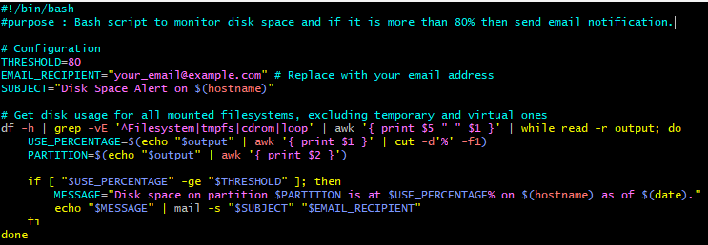

12. Bash script to monitor memory and if it is more than 80% then send email notification.
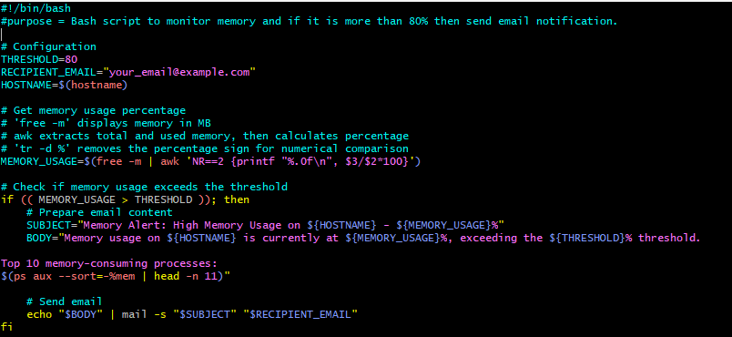

- Crontab Entries
- Added following crontab entries
- 1. April 5th Midnight
- 2. 5th of Every November, January, June if it is a Thursday
- 3. At 05 and 27th minutes of 9, 10, 11 hours every day
- 4. 34 minutes of 9th hour on 15th August
- 5. Every midnight
- 6. Every Weekend (Saturday night 11:59 PM)
- 7. After every reboot

